House Price Prediction

**Prepared by: Ahmed Aly Hassan Mahmoud**

**ID: 192006**

Following CRISP-DM (Cross Industry Standard Process for Data Mining) life cycle

1. Introduction:

The last decade has witnessed recurrent inconsistency in the U.S. housing market due to economic fluctuations and market changes. In the United States, the annual sales of existing single-family homes from 2005 to 2008 fell by 30%, while their average price dropped about 26%, and new construction declined by a 64% (Lombra, 2012).

Investment is a business activity that most people are interested in this globalization era. There are several objects that are often used for investment, for example, gold, stocks and property. In particular, property investment has increased significantly since 2011, both on demand and property selling

Investment in Real state is still the safest way as many people consider. As House prices increase every year, there is a need for a system to predict house prices in the future. House price prediction can help buyer, seller and broker to determine the selling price of a house and can help the customer to arrange the right time to purchase a house. There are many factors that influence the price of a house which include physical conditions, concept and location.

We need a proper prediction on the real estate and the houses in housing market we can see a mechanism that runs throughout the properties buying and selling. Buying a house will be a life time goal for most of the individual but there are lot of people making huge mistakes in United States of America right now when buying the properties. Most of the people are buying properties unseen from the people they don’t know by seeing the advertisements and all over the grooves coming around the America one of the common mistakes is buying the properties that are too expensive but its’ not worth it. In the housing market 2017, there is a survey that in the year 2016 the house sold in the America were about 5.42 million but the starter home inventory down up to 10.7% from 2015.

# This research aims to predict house prices in the city of Pittsburgh (Pennsylvania) with regression analysis. Selection of affect variables and regression analysis is used to determine the optimal coefficient in prediction.

2. Business Understanding

**2.1 Pervious work**

A variety of research has been developed to model housing prices and property values. First developed in the 60’s, hedonic regression has been the most common approach because it allows the total housing expenditure to be decomposed into the values of the individual components. Hedonic modeling is a widespread method in which a property is assumed to be a heterogeneous good and can be broken down into characteristics such as structural features

(e.g. year built, square footage, etc.) and locational factors (e.g. distance to commercial areas and major streets, etc.). The relationship between sale prices and housing characteristics along with neighborhood properties is measured by the hedonic regression (Rosen, 1974).

While the hedonic method is widely acceptable for accommodating real estate attributes to make predictions, one disadvantage is its complexity. Issues such as variable interactions, heteroscedasticity (non-constant variance), multi-collinearity, non-linearity and outlier data points can hinder the performance of the hedonic price model in housing prices. The second disadvantage is that hedonic models are limited within a specific studied location. Thus, hedonic models are generally used to gain insight into one particular market and it is difficult to generalize across different geographic regions (Sirmans et al., 2005).

**2.2 Currently**

The topic of real estate is not only the topic you just have to deal with. It can also be very interesting. There are plenty of TV Shows, for instance, [*Property Brothers*](https://en.wikipedia.org/wiki/Property_Brothers), of which plot is based on examples of people buying and renovating houses. This particular one is the most famous in the world and has been running already for almost a decade. For many people houses are also an investment that generates profits.

The descent in home values raises questions among home owners and shoppers regarding how accurately the value of homes can be assessed and what attributes determine the desirability of certain homes compared to other houses on the market.

####8-KomagometowneAnh_Thesis2016

This instability in the housing market necessitates the need for better methods for assessing housing prices. Consequently, the predictive accuracy of housing models has gained much attention among scholars and has been extensively studied. In particular, we are interested in methods that can estimate the value of a home based on its attributes in comparison to the current market price of similar houses. This ability to predict housing prices is important to anyone buying or selling a home, as well as to investors making asset allocation decisions.

Regardless of motives of buying and selling real estate, both sides agree on a price. It is always good to know **how much** a house is worth, what is the expected transaction price. Furthermore, it may be even more important **why** the price is like that, what has an impact on it.

Let us start with a couple of questions that allow to define and understand problems regarding house pricing.

* The seller does not know how to increase the value of the apartment so that the investment outlay is lower than the added value (e.g. building a pool may increase the price and renovating the bathroom is not worth it).
* The seller does not know how much to sell the apartment for (he makes an offer on the portal and does not know if the price is adequate).
* The buyer does not know how much the apartment is worth (as above, whether the price is adequate).
* Commercial problem: auction services may be interested in tools to support sellers and buyers (to highlight the sections in the offers that most affect the price).

An accurate prediction on the house price is important to prospective homeowners, developers, investors, appraisers, tax assessors and other real estate market participants, such as, mortgage lenders and insurers (Frew and Jud, 2003). Traditional house price prediction is based on cost and sale price comparison lacking of an accepted standard and a certification process. Therefore, the availability of a house price prediction model helps fill up an important information gap and improve the efficiency of the real estate market (Calhoun, 2003).

Over the years, the problem of property evaluation was solved in many different ways. Statistical tools used by analysts to explain house prices range from simple linear regression to more complex techniques such as artificial neural networks.

3. Data Understanding

The crucial element in machine learning task for which a particular attention should be

Clearly taken is the data. Indeed the results will be highly influenced by the data based on

Where did we find them, how are they formatted, are they consistent, is there any outlier and

So on. At this step, many questions should be answered in order to guarantee that the

Learning algorithm will be efficient and accurate.

**3.1 Data source:**

This dataset contains data on all Real Property parcels that have sold since 2013 in Allegheny County, PA.

Allegheny County (Pennsylvania) and the City of Pittsburgh both publish their data through the Western Pennsylvania Regional Data Center. The Western Pennsylvania Regional Data Center supports key community initiatives by making public information easier to find and use. The Data Center maintains Allegheny County and the City of Pittsburgh’s open data portal, and provides a number of services to data publishers and users. The Data Center also hosts datasets from these and other public sector agencies, academic institutions, and non-profit organizations. The Data Center is managed by the University of Pittsburgh’s Center for Social and Urban Research, and is a partnership of the University, Allegheny County and the City of Pittsburgh.

<https://catalog.data.gov/dataset/allegheny-county-property-sale-transactions>

Download link:

[https://catalog.data.gov/dataset/allegheny-county-property-sale transactions/resource/5a6688a2-d307-44a7-9bac-82af2f2b0509](https://catalog.data.gov/dataset/allegheny-county-property-sale%20transactions/resource/5a6688a2-d307-44a7-9bac-82af2f2b0509)

**3.2 Description of variables in the dataset**

Data contains 24 house features plus the price and the id columns, along with 307K observations. Below the Table describes the variables in the data set

|  |  |  |  |
| --- | --- | --- | --- |
| **Field Name** | **Field Description** | **Example** | **Additional Data Details** |
| PARID | Parcel Identification Number | 0030A00190000000 | A 16 character unique identifier for the parcel. |
| PROPERTYHOUSENUM | Property Location House Number | 3016 | House Number for the physical location of property; may be zero or blank. |
| PROPERTYFRACTION | Property Location House Number Fraction | 43832 | Continued House Number information for the physical location of property; such as 1/2, the house number ending range, or a letter. |
| PROPERTYADDRESSDIR | Property Location Street Directional | (e.g. N, S, etc….) | Directional indicator of the street name for the physical location of the property. |
| PROPERTYADDRESSSTREET | Property Location Street Name | HARCUM | Street name for the physical location of the property. |
| PROPERTYADDRESSSUF | Property Location Street Type | WAY | Suffix of the street name for the physical location of the property. |
| PROPERTYADDRESSUNITDESC | Property Location Unit Description | (e.g. UNIT, APT, STE, BLDG, etc…) | Unit description for the physical location of the property. |
| PROPERTYUNITNO | Property Location Unit Number | (e.g. 1, 3C, 115A, B13, etc….) | Unit number for the physical location of the property. |
| PROPERTYCITY | Property Location City Name | PITTSBURGH | City where the property is physically located. |
| PROPERTYSTATE | Property Location State Name | PA | State where the property is physically located. |
| PROPERTYZIP | Property Location Zip code, first 5 digits | 15203 | Zip Code where the property is physically located. |
| SCHOOLCODE | School District Code | 47 | School district number associated with specified parcel. |
| SCHOOLDESC | School District Name | City Of Pittsburgh | School district name associated with specified parcel. |
| MUNICODE | Municipality Code (Tax District) | 116 | Municipality number associated with specified parcel. |
| MUNIDESC | Municipality Name | 16th Ward - PITTSBURGH | Municipality name associated with specified parcel. |
| RECORDDATE | Date Sale was Recorded | 41969 | Date the sale was recorded  in the Department of Real Estate. Format is mm/dd/yyyy. |
| SALEDATE | Sale Date | 41947 | Date the sale occurred. Format is mm/dd/yyyy. |
| PRICE | Sale Price | 35000 | Amount paid for the sale  (also called consideration). |
| DEEDBOOK | Deed Book Number | 15811 | Cross-reference to the physical book number  where the deed is on file in the Department of Real Estate. |
| DEEDPAGE | Page Number | 248 | Page within the specified deed book  corresponding to the first page of  this physical deed. |
| SALECODE | Sale Validation Code | AA | A subjective categorization code denoting whether or not the sale price was representative of current market value. These categorizations are subject to change as sales are reviewed by the Office of Property Assessments or during a reassessment. See further explanation in the "Sale Validation Codes Details" resource. |
| SALEDESC | Sale Validation Code Description | SALE NOT ANALYZED | A description of the code denoting whether or not the sale price was representative of current market value. These categorizations are subject to change as sales are reviewed by the Office of Property Assessments or during a reassessment. See further explanation in the "Sale Validation Codes Details" resource. |
| INSTRTYP | Instrument Type | SD | A code describing the type of document used to record the real property transfer. |
| INSTRTYPDESC | Instrument Description | Sheriffs Deed | A description of the type of document used to record the real property transfer. |

4. Data Preparation

**4.1 Reading the Dataset**

**Mongodb installation and dataload**

**Read from Database source (Mongodb)**

MongoDB is an open-source document database and leading NoSQL database. MongoDB is written in C++. MongoDB is a document database, which means it stores data in JSON-like documents. We believe this is the most natural way to think about data, and is much more expressive and powerful than the traditional row/column model.

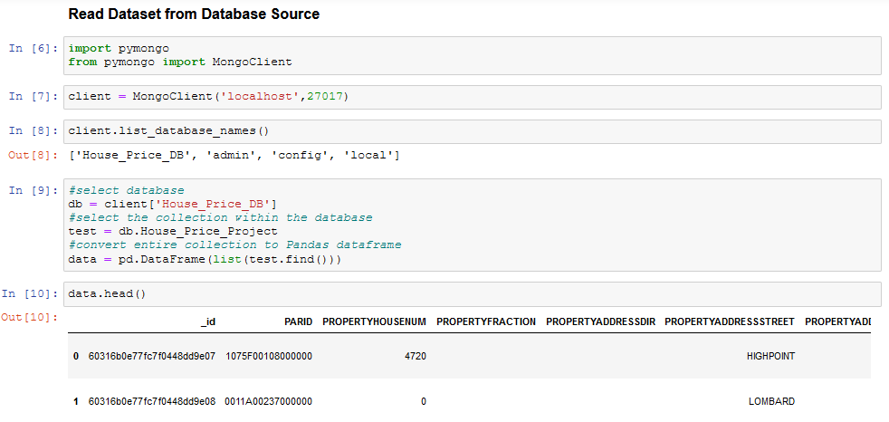

**Read Dataset as CSV file in Pandas**

As a second option we can read the dataset from the csv file we downloaded. We will use the read_csv() function from Pandas Python package:

**import pandas as pd**

**import numpy as np**

data = pd.read_csv('House_Price.csv')

## **Getting A Feel of the Dataset**

Let’s display the first few rows of the dataset to get a feel of it:

**data.head()**

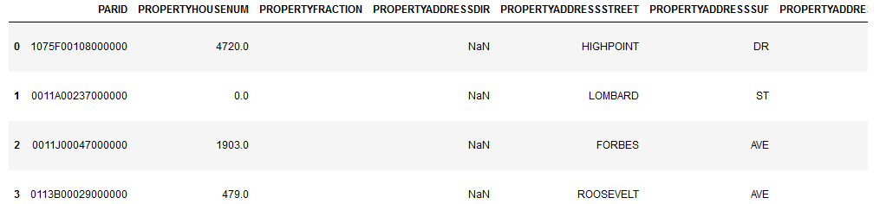

Now, let’s get statistical information about the numeric columns in our dataset. We want to know the mean, the standard deviation, the minimum, the maximum, and the 50th percentile (the median) for each numeric column in the dataset:

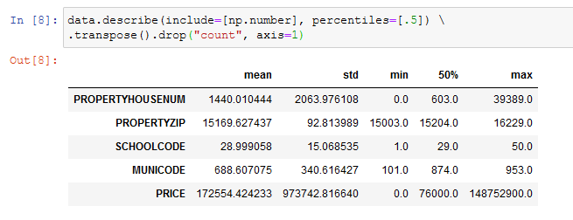

From the table above, we can see, for example, that the average Amount paid for the sale in our dataset is 172554 $ with a standard deviation of 973742 .Similarly, we can get a lot of information about our dataset variables from the table.

Then, we move to see statistical information about the non-numerical columns in our dataset:

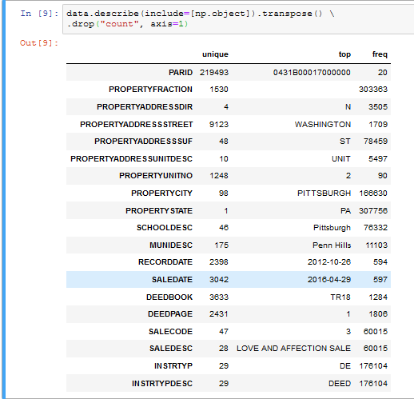

In the table we got, count represents the number of non-null values in each column, unique represents the number of unique values, top represents the most frequent element, and freq represents the frequency of the most frequent element.

## **Data Cleaning**

## **Dealing with Missing Values**

We should deal with the problem of missing values because some machine learning models don’t accept data with missing values. Firstly, let’s see the number of missing values in our dataset. We want to see the number and the percentage of missing values for each column that actually contains missing values.

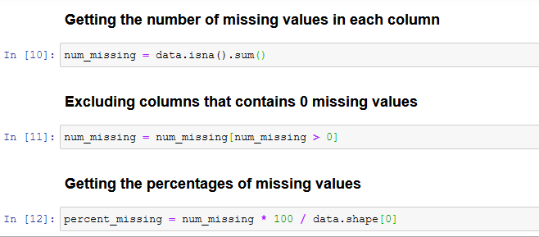

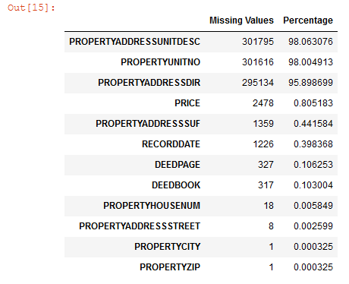

* + 1. **Imputation**

Missing value imputation is one of the biggest challenges encountered by the data scientist. In addition, most machine learning algorithms are not powerful enough to handle missing data. Missing data can lead to ambiguity, misleading conclusions, and results [27]. There are two types of missing values [28]; the first type is called missing completely at random (MCAR). MCAR can be expressed as: (𝑅|𝑋,,)=𝑃(𝑅|𝜇)

Where 𝑅 is the response indicator variables, 𝑋 are independent of data variables, and 𝑍 is latent. The second type is called missing at random (MAR), which can be expressed as:

(𝑅=𝑟|𝑋=𝑥,𝑍=𝑧,𝜇)=(𝑅=𝑟|𝑋0=𝑥0)

There are two methods of handling missing data, namely ignoring missing data and imputation of missing data. Ignoring missing data is a simple technique which deletes the cases that contain missing data. The disadvantages of this method are that it reduces the size of the dataset, and it uses a different sample size for different variables. Imputation of missing data is a technique that replaces missing data with some reasonable data values [27]. However, the imputation of missing data method has two types, single imputation, and multiple imputations. Single imputation contains several approaches, such as mean imputation and regression imputation. Mean imputation is the most common approach of missing data replacement [27]. It replaces the missing data with sample mean or median. However, it has a disadvantage which is if missing data are enormous in number, then all those data are replaced with the same imputation mean, which leads to change in the shape of the distribution. Regression imputation is a technique based on the assumption of the linear relationship between the attributes. The advantage of regression imputation over mean imputation is that it was able to preserve the distribution shape [27].

* + 1. **Deleting Unimportant Columns**

**According to the dataset dictionary hereunder some columns that can be removes which doesn’t have a crucial impact on the house pricing issue itself.**

1. **PARID**: A 16 character unique identifier for the parcel.
2. **PROPERTYHOUSENUM:** House Number for the physical location of property; may be zero or blank.
3. **PROPERTYFRACTION**: Continued House Number information for the physical location of property; such as 1/2, the house number ending range, or a letter.
4. **PROPERTYADDRESSDIR**: Directional indicator of the street name for the physical location of the property.
5. **PROPERTYADDRESSSUF:** Suffix of the street name for the physical location of the property.
6. **PROPERTYADDRESSUNITDESC**: Unit description for the physical location of the property.
7. **PROPERTYUNITNO**: Unit number for the physical location of the property.
8. **PROPERTYSTATE:** State where the property is physically located.
9. **PROPERTYZIP:** Zip Code where the property is physically located.
10. **SCHOOLDESC:** School district name associated with specified parcel.
11. **MUNICODE**: Municipality number associated with specified parcel.
12. **MUNIDESC**: Municipality name associated with specified parcel.
13. **RECORDDATE**: Date the sale was recorded in the Department of Real Estate. Format is mm/dd/yyyy.
14. **DEEDBOOK**: Cross-reference to the physical book number where the deed is on file in the Department of Real Estate.
15. **DEEDPAGE**: Page within the specified deed book corresponding to the first page of this physical deed.
16. **INSTRTYP**: A code describing the type of document used to record the real property transfer.
17. **INSTRTYPDESC**: A description of the type of document used to record the real property transfer.
18. **SALECODE:** A subjective categorization code denoting whether or not the sale price was representative of current market value. These categorizations are subject to change as sales are reviewed by the Office of Property Assessments or during a reassessment. See further explanation in the "Sale Validation Codes Details" resource.
    * 1. **Deleting Duplicates & null values**

An important part of Data analysis is analyzing Duplicate Values and removing them. We found 22285 records are duplicated through the dataset, which will mislead during the data analysis and in model building stage.

Then, we dropped null values throughout the data cleaning process. Now Data shape is (283318, 6)

1. **Exploratory Data Analysis**

**5.1 Relationship between PROPERTYCITY and PRICE.**

Definitely the property price is changing by the City where the property is physically located. For the below relationship we can find that the highest property price is in PITTSBURGH city which equal 124400000 $. The second highest property price is in the same city with amount of 60250000 $.

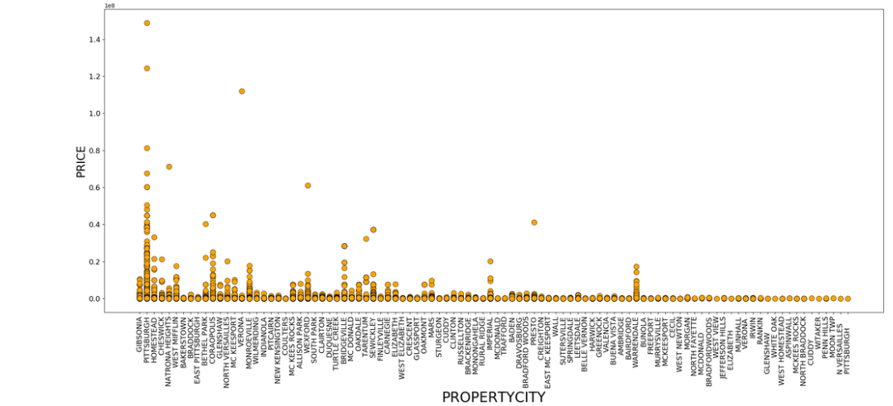

* 1. **Relationship between PROPERTYCITY and number of properties.**

From the below figure we can conclude that the PITTSBURGH city has the most sold properties with count of 166634 property. Which is almost 54 % of the total properties in the whole dataset.

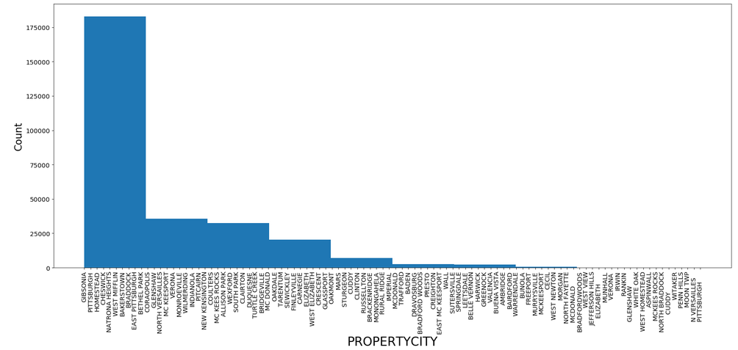

* 1. **Boxplot to check Price outliers**

Below figure indicates that there are some outliers that should be removed in order to avoid it bad impact on model prediction. They will be removed in the coming steps

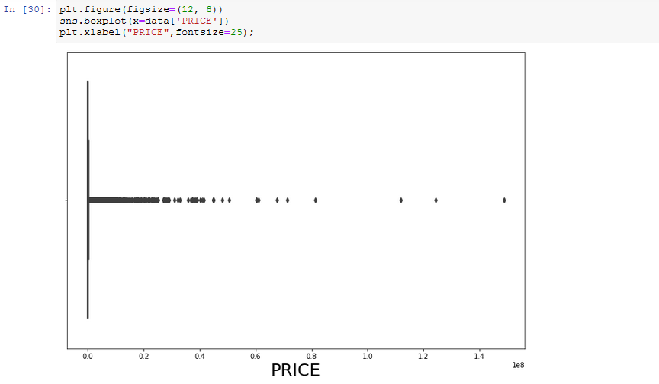

## **Time series analysis using Prophet in Python**

Prophet is a facebooks’ open source time series prediction. Prophet decomposes time series into trend, seasonality and holiday. It has intuitive hyper parameters which are easy to tune.

# Advantages of using Prophet

* Accommodates seasonality with multiple periods
* Prophet is resilient to missing values
* Best way to handle outliers in Prophet is to remove them
* Fitting of the model is fast
* Intuitive hyper parameters which are easy to tune

The below shows the Price distribution over the years from 2012 till 2021, we can find that the highest price occurred at 2016.

The second record is found recorder in 2013.

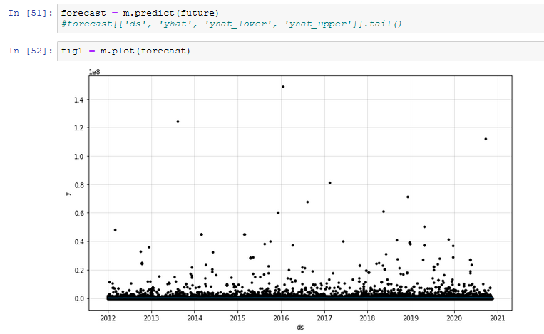

**Price forecast along different period of time - Yearly**

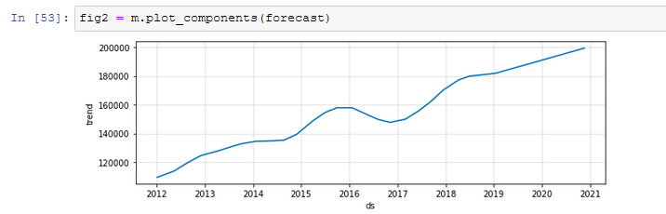

We can find that the price was increasing from 2012 to 2016 then it slightly fall at 2017. It has become upwards again gradually till the end of 2020.

**Price forecast along different period of time – Day of the week**

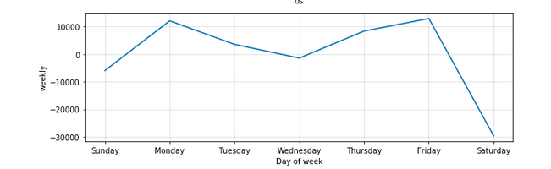

Highest prices are recorded on Mondays and Fridays. Whereas Saturdays is almost the lowest which is normal behavior because it’s the weekend.

**Price forecast along different period of time – Day of Year**

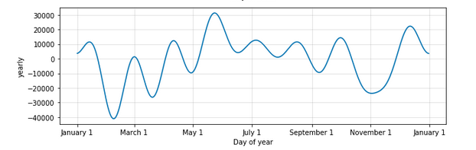

Lowest prices was recorded January and March and the highest sale price is found between May and July.

## **Feature Engineering**

# Feature Engineering on Categorical Data

# While a lot of advancements have been made in various machine learning frameworks to accept complex categorical data types like text labels. Typically any standard workflow in feature engineering involves some form of *transformation* of these categorical values into numeric labels and then applying some *encoding scheme* on these values. We load up the necessary essentials before getting started.

## **Transforming Nominal Attributes:** Nominal attributes consist of discrete categorical values with no notion or sense of order amongst them. The idea here is to transform these attributes into a more representative numerical format which can be easily understood by downstream code and pipelines. Let’s look at a new dataset pertaining to video game sales. This dataset is also available on [**Kaggle**](https://www.kaggle.com/gregorut/videogamesales) as well as in my [**GitHub**](https://github.com/dipanjanS/practical-machine-learning-with-python/tree/master/notebooks/Ch04_Feature_Engineering_and_Selection) repository.

Learning models accept only numbers as input, and since our dataset contains categorical features, we need to encode them in order for our dataset to be suitable for modeling. We will encode our categorical features using label encoding technique which transforms the categorical variable into a number of binary variables based on the number of unique categories in the categorical variable

We need to convert the following columns: PROPERTYCITY, PROPERTYADDRESSSTREET and SALEDESC

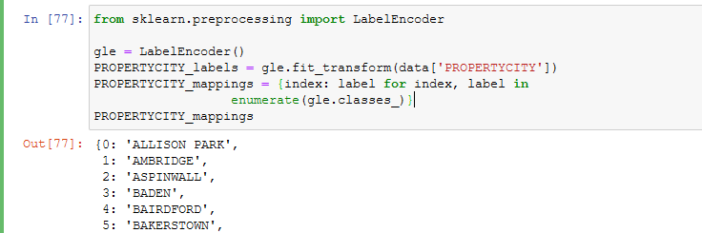

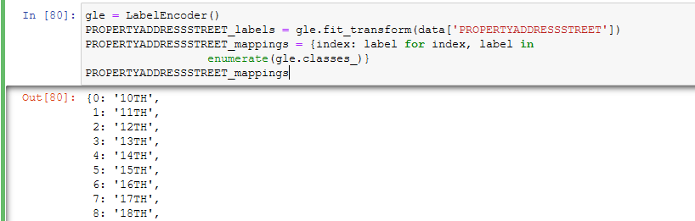

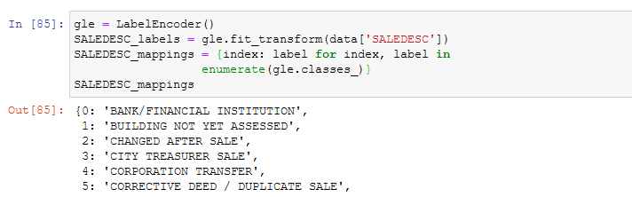

**Now, how data looks like after all these conversions**

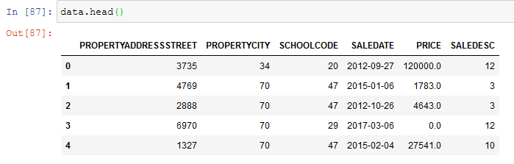

# Outlier Removal

# [Outliers](https://statisticsbyjim.com/glossary/outliers/) are unusual values in your dataset, and they can distort statistical analyses and violate their assumptions. Unfortunately, all analysts will confront [outliers](https://statisticsbyjim.com/glossary/outliers/) and be forced to make decisions about what to do with them. Given the problems they can cause, you might think that it’s best to remove them from your data. But, that’s not always the case. Removing outliers is legitimate only for specific reasons.

Outliers can have many causes, such as:

* Measurement or input error.
* Data corruption.

# 

# Remove zero values

# We have to drop rows which contain zero records of Price column because there is no meaning to have a price equal to zero. So, I decided to delete all rows with zero value via following method.

# 

# Data Normalization

**Data Normalization** is a common practice in machine learning which consists of transforming **numeric columns** to a **common scale.** In machine learning, some feature values differ from others multiple times. The features with higher values will dominate the leaning process. However, it does not mean those variables are more important to predict the outcome of the model. **Data normalization** transforms multiscale data to the same scale. After normalization, all variables have a **similar influence** on the model, improving the stability and performance of the learning algorithm.

# There are multiple normalization techniques in statistics. In this project I used the method provided by sklearn package: [sklearn.preprocessing](https://scikit-learn.org/stable/modules/classes.html#module-sklearn.preprocessing).normalize

**Normalization** of datasets is a common requirement for many machine learning estimators implemented in scikit-learn; they might behave badly if the individual features do not more or less look like standard normally distributed data: Gaussian with zero mean and unit variance.

In practice we often ignore the shape of the distribution and just transform the data to center it by removing the mean value of each feature, then scale it by dividing non-constant features by their standard deviation.

For instance, many elements used in the objective function of a learning algorithm (such as the RBF kernel of Support Vector Machines or the l1 and l2 regularizers of linear models) assume that all features are centered around zero and have variance in the same order. If a feature has a variance that is orders of magnitude larger than others, it might dominate the objective function and make the estimator unable to learn from other features correctly as expected.

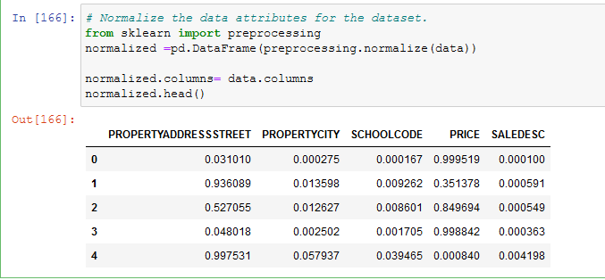

As we can notice that all values are between 0 and 1, so they are now meaningful and at the same scale and ready for modeling to get significance results.

# Train – Test Split

The train-test split is a technique for evaluating the performance of a machine learning algorithm.

It can be used for classification or regression problems and can be used for any supervised learning algorithm.

The procedure involves taking a dataset and dividing it into two subsets. The first subset is used to fit the model and is referred to as the training dataset. The second subset is not used to train the model; instead, the input element of the dataset is provided to the model, then predictions are made and compared to the expected values. This second dataset is referred to as the test dataset.

* Train Dataset: Used to fit the machine learning model.
* Test Dataset: Used to evaluate the fit machine learning model.

The objective is to estimate the performance of the machine learning model on new data: data not used to train the model. This is how we expect to use the model in practice. Namely, to fit it on available data with known inputs and outputs, then make predictions on new examples in the future where we do not have the expected output or target values. The train-test procedure is appropriate when there is a sufficiently large dataset available.

## **6. Modeling Building**

* 1. **Multiple Linear Regression:** Multiple Linear Regression (MLR) is a supervised technique used to estimate the relationship between one dependent variable and more than one independent variables. Identifying the correlation and its cause-effect helps to make predictions by using these relations, the prediction accuracy of the model is essential; the complexity of the model is of more interest. However, Multiple Linear Regression is prone to many problems such as multi collinearity, noises, and overfitting, which effect on the prediction accuracy.

Regularized regression plays a significant part in Multiple Linear Regression because it helps to reduce variance at the cost of introducing some bias, avoid the overfitting problem and solve ordinary least squares (OLS) problems. There are two types of regularization techniques L1 norm (least absolute deviations) and L2 norm (least squares). L1 and L2 have different cost functions regarding model complexity

### **Algorithm Formulation**

When implementing linear regression of some dependent variable 𝑦 on the set of independent variables 𝐱 = (𝑥₁, …, 𝑥ᵣ), where 𝑟 is the number of predictors, you assume a linear relationship between 𝑦 and 𝐱: 𝑦 = 𝛽₀ + 𝛽₁𝑥₁ + ⋯ + 𝛽ᵣ𝑥ᵣ + 𝜀. This equation is the **regression equation**. 𝛽₀, 𝛽₁, …, 𝛽ᵣ are the **regression coefficients**, and 𝜀 is the **random error**.

Linear regression calculates the **estimators** of the regression coefficients or simply the **predicted weights**, denoted with 𝑏₀, 𝑏₁, …, 𝑏ᵣ. They define the **estimated regression function** (𝐱) = 𝑏₀ + 𝑏₁𝑥₁ + ⋯ + 𝑏ᵣ𝑥ᵣ. This function should capture the dependencies between the inputs and output sufficiently well.

The **estimated** or **predicted response**, (𝐱ᵢ), for each observation 𝑖 = 1, …, 𝑛, should be as close as possible to the corresponding **actual response** 𝑦ᵢ. The differences 𝑦ᵢ - (𝐱ᵢ) for all observations 𝑖 = 1, …, 𝑛, are called the **residuals**. Regression is about determining the **best predicted weights**, that is the weights corresponding to the smallest residuals.

To get the best weights, you usually **minimize the sum of squared residuals** (SSR) for all observations 𝑖 = 1, …, 𝑛: SSR = Σᵢ(𝑦ᵢ - 𝑓(𝐱ᵢ))². This approach is called the **method of ordinary least squares**.

### **Regression Performance**

The variation of actual responses 𝑦ᵢ, 𝑖 = 1, …, 𝑛, occurs partly due to the dependence on the predictors 𝐱ᵢ. However, there is also an additional inherent variance of the output.

The **coefficient of determination**, denoted as 𝑅², tells you which amount of variation in 𝑦 can be explained by the dependence on 𝐱 using the particular regression model. Larger 𝑅² indicates a better fit and means that the model can better explain the variation of the output with different inputs.

The value 𝑅² = 1 corresponds to SSR = 0, that is to the **perfect fit** since the values of predicted and actual responses fit completely to each other.

**Underfitting** occurs when a model can’t accurately capture the dependencies among data, usually as a consequence of its own simplicity. It often yields a low 𝑅² with known data and bad generalization capabilities when applied with new data.

**Overfitting** happens when a model learns both dependencies among data and random fluctuations. In other words, a model learns the existing data too well. Complex models, which have many features or terms, are often prone to overfitting. When applied to known data, such models usually yield high 𝑅². However, they often don’t generalize well and have significantly lower 𝑅² when used with new data.

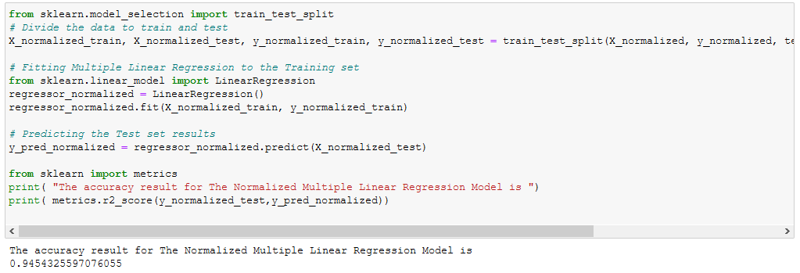

# Random Forest Regression:

Random forest description by example: Let’s start with an actual problem. Imagine you want to buy real estate, and you want to figure out what comprises a good deal so that you don’t get taken advantage of.

The obvious thing to do would be to look at historic prices of houses sold in the area, then create some kind of decision criteria to summarize the average selling prices given the real-estate specification. You can use the decision chart to evaluate whether the listed price for the apartment you are considering is a bargain or not. It could look like this:

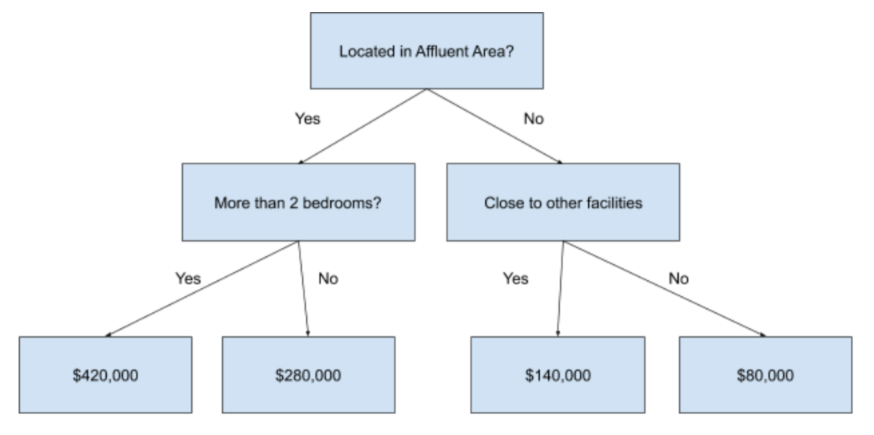

The chart represents a decision tree through a series of yes/no questions, which lead you from the real-estate description (“3 bedrooms”) to its historic average price. You can use the decision tree to predict what the expected price of a real estate would be, given its attributes.

However, you could come up with a distinctly different decision tree structure:

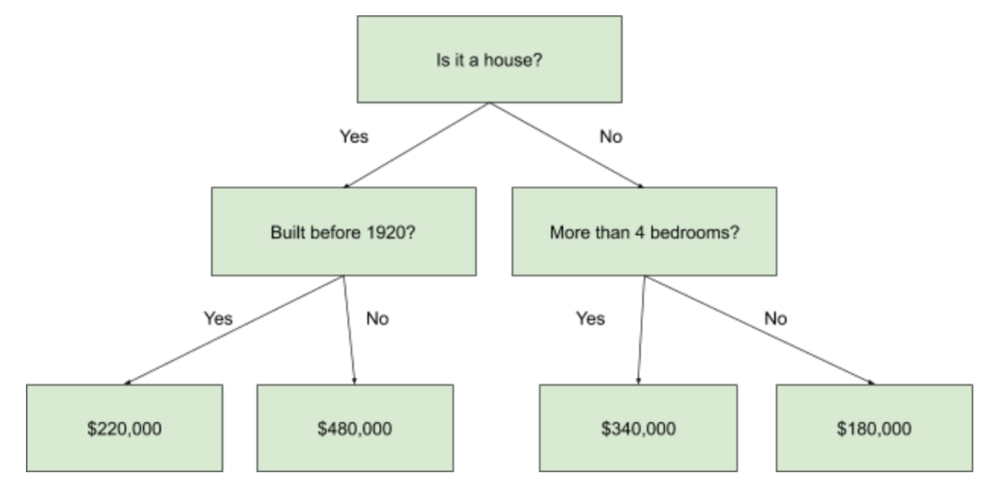

This would also be a valid decision chart, but with totally different decision criteria. These decisions are just as well-founded and show you information that was absent in the first decision tree.

The random forest regression algorithm takes advantage of the ‘wisdom of the crowds’. It takes multiple (but different) regression decision trees and makes them ‘vote’. Each tree needs to predict the expected price of the real estate based on the decision criteria it picked. Random forest regression then calculates the average of all of the predictions to generate a great estimate of what the expected price for a real estate should be.

### **Business use cases of random forest:**

* 1. **Predict future prices/costs:** Whenever your business is trading products or services (e.g. raw materials, stocks, labors, service offerings, etc.), you can use random forest regression to predict what the prices of these products and services will be in the future.
  2. **Predict future revenue:** Use random forest regression to model your operations. For example, you can input your investment data (advertisement, sales materials, cost of hours worked on long-term enterprise deals, etc.) and your revenue data, and random forest will discover the connection between the input and output. This connection can be used to predict how much revenue you will generate based on the growth activity that you pick (marketing, direct to customer sales, enterprise sales, etc.) and how much you are willing to spend on it.
  3. **Compare performance:** Imagine that you’ve just launched a new product line. The problem is, it’s unclear whether the new product is attracting more (and higher spending) customers than the existing product line. Use random forest regression to determine how your new product compares to your existing ones.

## **Random forest approaches:**

It is supervised in the sense that during training, it learns the mappings between inputs and outputs. For example, an input feature (or independent variable) in the training dataset would specify that an apartment has “3 bedrooms” (feature: *number of bedrooms*) and this maps to the output feature (or target) that the apartment will be sold for “$200,000” (target: *price sold*).

Ensemble algorithms combine multiple other machine learning algorithms, in order to make more accurate predictions than any underlying algorithm could on its own. In the case of random forest, it ensembles multiple decision trees into its final decision.

Random forest can be used on both regression tasks (predict continuous outputs, such as price) or classification tasks (predict categorical or discrete outputs). Here, we will take a deeper look at using random forest for regression predictions.

## **The random forest algorithm follows a two-step process:**

* 1. **Builds n decision tree repressors (estimators)**. The number of estimators *n* [defaults to 100 in Scikit Learn](https://scikit-learn.org/stable/modules/generated/sklearn.ensemble.RandomForestRegressor.html) (the machine learning Python library), where it is called *n_estimators*. The trees are built following the specified hyper parameters (e.g. minimum number of samples at the leaf nodes, maximum depth that a tree can grow, etc.).
  2. **Average prediction across estimators**. Each decision tree regression predicts a number as an output for a given input. Random forest regression takes the average of those predictions as its ‘final’ output.

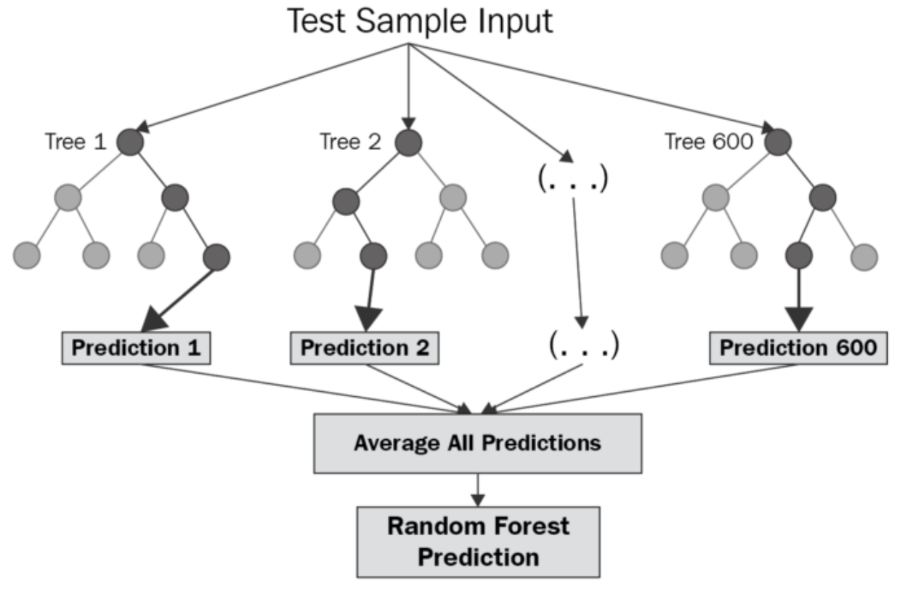

### **How to improve the RFR model:**

1. **Specify the maximum depth of the trees:** By default, trees are expanded until all leaves are either pure or contain less than the minimum samples for the split. This can still cause the trees to overfit or underfit. Play with the hyper parameter to find an optimal number for max_depth.
2. **Increase or decrease the number of estimators:** How does changing the number of trees affect performance? More trees usually means higher accuracy at the cost of slower learning. If you wish to speed up your random forest, lower the number of estimators. If you want to increase the accuracy of your model, increase the number of trees.
3. **Specify the maximum number of features to be included at each node split:** This depends very heavily on your dataset. If your independent variables are highly correlated, you’ll want to decrease the maximum number of features. If your input attributes are not correlated and your model is suffering from low accuracy, increase the number of features to be included.

**Model performance output**

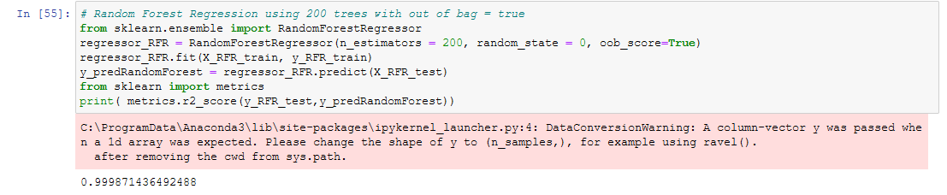

## **7. Evaluation**

## **7.1 Coefficient of Determination – R2 score**

In the domain of Data Science, to solve any model it is very necessary for the engineer/developer to evaluate the [efficiency of a model](https://www.askpython.com/python/examples/impute-missing-data-values) prior to applying it to the [dataset](https://www.askpython.com/python/examples/standardize-data-in-python). The evaluation of the model is based on certain error metrics. The coefficient of determination is one such error metric.

Coefficient of Determination also popularly known as R square value is a regression error metric to evaluate the accuracy and efficiency of a model on the data values that it would be applied to.

R square values describe the performance of the model. It describes the variation in the response or target variable which is predicted by the independent variables of the data model.

Thus, in simple words we can say that, the R square value helps determine how well the model is blend and how well the output value is explained by the determining(independent) variables of the dataset.

The value of R square ranges between [0,1]. Have a look at the below formula!

R2= 1- SSres / SStot

* SSres represents the sum of squares of the residual errors of the data model.
* SStot represents the total sum of the errors.

**R2 for linear Regression Model:**

The accuracy result for The Normalized Multiple Linear Regression Model: 0.945

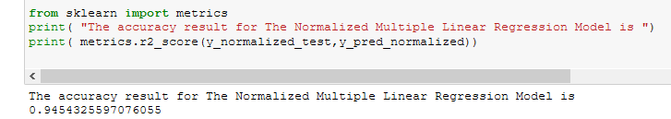

**R2 for Random Forest Model:**

The accuracy of the model = 0.999871436492488



**7.2 Root Mean Square Error (RMSE)**

Mean Square error is one such error metric for judging the accuracy and error rate of any machine learning algorithm for a regression problem.

So, MSE is a risk function that helps us determine the average squared difference between the predicted and the actual value of a feature or variable.

RMSE is an acronym for **Root Mean Square Error**, which is the **square root of value obtained from Mean Square Error** function.

**Using RMSE, we can easily plot a difference between the estimated and actual values of a parameter of the model**.

By this, we can clearly judge the efficiency of the model.

Usually, a RMSE score of less than 180 is considered a good score for a moderately or well working algorithm. In case, the RMSE value exceeds 180, we need to perform feature selection and hyper parameter tuning on the parameters of the model.

**RMSE for linear Regression Model:**

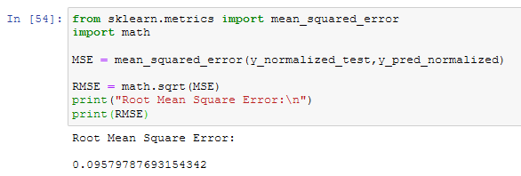

**RMSE for Random Forest Model:**

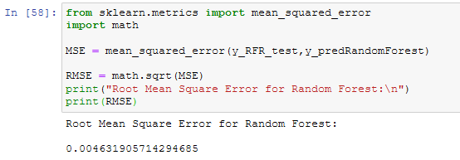

**9. Model Deployment**

1. **Convert the model to deployable file using pickle**

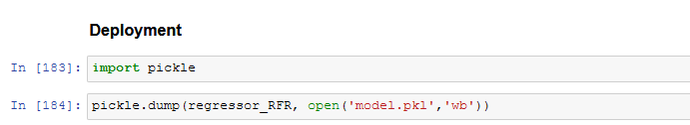

1. **Using flask as intermediate webserver to read the model and handle http request**

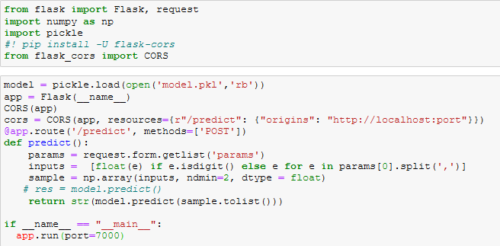

1. **Create UI (website) by using Asp MVC .Net core.**

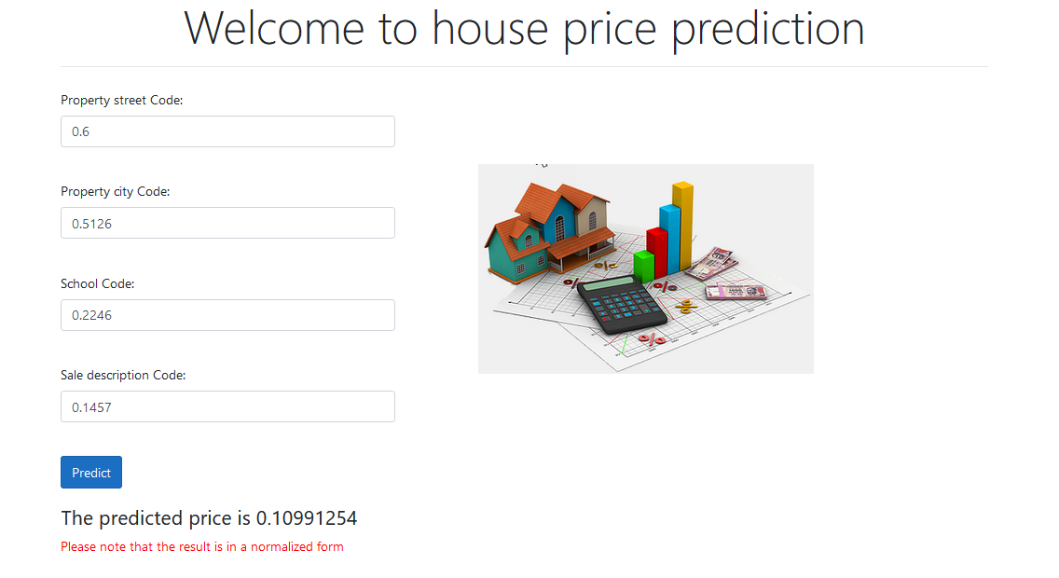

**10. Conclusion**

In this project, we built several regression models to predict the price of some house given some of the house features. We evaluated and compared each model to determine the one with highest performance. We also looked at how some models rank the features according to their importance. In this project, we followed the data science process starting with getting the data, then cleaning and preprocessing the data, followed by exploring the data and building models, then evaluating the results and communicating them with visualizations.

As a recommendation, we advise to use this model (or a version of it trained with more recent data) by people who want to buy a house in the area covered by the dataset to have an idea about the actual price. The model can be used also with datasets that cover different cities and areas provided that they contain the same features. We also suggest that people take into consideration the features that were deemed as most important as seen in the previous section; this might help them estimate the house price better.